Northeastern Section, American Nuclear Society
Policy 1 – ANS-NE Records Management Policy

- Purpose
The purpose of this policy is to present a formal procedure for the retention of documents for the Northeastern Section, American Nuclear Society. This policy will identify which documents will be archived, when and where they will be archived and the duration of their archival.
- Overview
The selection of documents to be retained and the minimum duration of their retention are dictated by several requirements and preferences. Factors that dictate the requirements of this retention policy include the following:
- Federal and State requirements for non-profit organizations
- Requirements from the American Nuclear Society National Headquarters
- Decisions by the American Nuclear Society Northeastern Section as to additional documents and records to be retained.

Historically, documents have been retained by the current officers or board members. Some documents, such as past meeting presentations reside on the ANS-NE Public Website. Some other documents such as procedures and meeting minutes were stored sporadically on a non-public document ANS-NE webpage.

This presents several problems:

- For documents that are retained for several years, a significant number of documents must be transferred during installation of new officers and directors.
- Retention periods for various documents are not clearly defined.
- Archive procedures will likely vary between individuals.
- A formal backup mechanism is not in place.
The retained documents will now be stored on the American Nuclear Society National Organization File Archive System (FAS). This system provides an online archive and retrieval system available to local sections. This system allows extensive storage capability that can be organized by category and year. The organization of this storage can be modified at the discretion of the local section. Attachment 1 provides a screen capture of the current ANS-NE Records Site on the FAS. Many portions of these folders have already been populated with stored documents. The ANS-NE Records Site is located at: http://remote.ans.org/ui/#/. Each of the ANS-NE officers has been given individual passwords which are required for access. The ANS-NE Chair shall maintain the FAS access request form. Officers shall request a password from the Local Sections Committee administrator if they have lost theirs or request the section Chair to submit a revised access request form.

- Formal Requirements

- Federal Documents
The ANS-NE, having revenues of less than $50,000 may file either IRS Form 990 EZ or the IRS e-Postcard electronically. Either method is due on the 15th day of the 5th month after the end of the organization's fiscal year. IRS Form 990 (for larger non-profits) asks whether the non-profit has a written document retention policy. Although not required by tax law, the IRS views this as a good governance Practice.
The e-Postcard filing is a paperless system filed online. It is recommended that whichever method is used in a particular year, that some electronic copy be generated for subsequent archiving. If an e-Postcard is filed, a screen capture or print to PDF should be performed.
Each annual IRS filing shall be archived on the ANS-NE Records Site within a month of the filing.
Tax records should be retained for a minimum of seven years for federal purposes.
In addition to yearly tax filings, any documents relating to federal non-profit status shall be archived on the ANS-NE Records Site. For example, the original IRS letter confirming non-profit status is currently stored at the ANS-NE Records site.
In addition to yearly federal tax records, any historical records such as federal non-profit status confirmation shall be archived.

- State Requirements
Numerous records for Massachusetts non-profits must be provided. Massachusetts maintains a Corporations Online Filing System, which maintains these records. Attachment 2 provides the list of records maintained on the Massachusetts Corporations Online Filing System. The Annual Report and Certificate of Change of Directors must be updated annually. Other records must be updated whenever modified.
It should be noted that the Massachusetts online system only contains the current records. Therefore, ANS-NE is responsible for capturing and archiving previous versions of these records.

Any state filings shall be captured electronically and stored at the ANS Records site. These should be retained for a minimum of seven years.
Massachusetts Department of Revenue (DOR) retains tax information for 4 years.

- ANS National Requirements

ANS National requires that an annual financial report and a current list of officers be provided. These are due by the end of August (by August 1 for consideration of meritorious section award. In addition ANS-NE conducts an annual audit of the organization’s financial records.

All of these documents shall be stored in the ANS-NE Records Site within a month of their issuance. For historical purposes, the annual reports and officer lists should be maintained indefinitely. Audit reports should be maintained for at least 7 years.

ANS National requires that each local section adopt a set of bylaws and rules. These shall be archived on the ANS-NE Records Site.

- Other Documents

These are documents that are not required by state or federal agencies or by the ANS National organization. These are archived for historical or informational content. The following documents shall be archived on the ANS-NE Records Site:
- Meeting Minutes
- ANS-NE Procedures, Policies, Etc.
- MA Tax Exempt Certificate
- ANS-NE Activity List
- Forms and Sample Documents
- Current ANS-NE Mailing List
- Members List (Paid up members at the end of the program year)
- Strategic Plans and Implementing Documents
- Agreements with other societies
- Election Documents (Nomination Committee Reports and Election Audit Reports) (Do not include specific voter results)

Documents that ANS-NE would like to be available to the general public are best placed on the ANS-NE public website. The following documents shall be available on the ANS-NE public website

- Current ANS-NE Bylaws & Rules, Procedures, Policies, Etc.
- Current Activity List
- Meeting Presentations
- Recent Meeting Minutes (12 months)
- Current MA Tax Exempt Certificate.
- Agreements with other societies
Additional documents may be archived at the discretion of ANS-NE on a case by case basis.
- Retention Schedule
The ANS-NE documentation retention Schedule is provided in Attachment 3, ANS-NE Records Management Matrix. Checks should be made to ensure that the schedule is being applied consistently. At the end of each program year a two-person committee consisting of the Vice Chair and the Secretary shall review records on the ANS-NE Records Site as follows:
- Records have been properly stored in accordance with this procedure.
- Any records beyond their required retention requirements shall be identified by type and deleted when applicable.
- A listing of any open issues shall be created and responsibilities assigned.

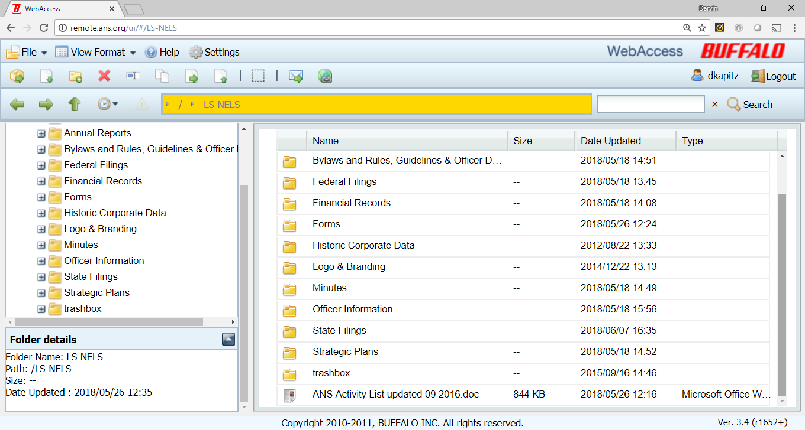

Attachment 2
Commonwealth of Massachusetts – Corporations Online Filing System

The following items are included in the Massachusetts Corporations Online Filing System:
- Annual Report
- Articles of Amendment
- Certificate of Appointment of Resident Agent
- Certificate of Change of Address of Resident Agent
- Certificate of Change of Directors or Officers
- Certificate of Change of Fiscal Year End
- Certificate of Change of Principle Office
- Related Articles of Organization

Document Retention Schedule
Folder | Document | Retention Date | Duration | Cognizant Individual
Federal Filings | E-copy of 990-EZ or e-Postcard | One month from filing | 7 years | Treasurer
Federal Filings | Historical Federal records | One month from filing | Permanently | Secretary
State Filings | Annual Report | One month from filing | Permanently | Secretary
State Filings | Articles of Amendment | One month from any modification | Permanently | Secretary
State Filings | Certificate of Appointment of Resident Agent | One month from any modification | Permanently | Secretary
State Filings | Certificate of Change of Address of Resident Agent | One month from any modification | Permanently | Secretary
State Filings | Certificate of Change of Directors or Officers | One month from election of new officers | Permanently | Secretary
State Filings | Certificate of Change of Fiscal Year End | One month from any modification | Permanently | Secretary
State Filings | Certificate of Change of Principle Office | One month from any modification | Permanently | Secretary
State Filings | Related Articles of Organization | One month from any modification | Permanently | Secretary
Financial Reports | ANS-NE Annual Financial Report | One month after approval | 7 years | Treasurer
Financial Reports | Audit Reports | One month after approval | 7 years | Audit Committee
Financial Reports | Check register, bank statements, meeting financial tallies, receipts and expenses. | Monthly | 7 years | Treasurer
`Financial Reports | Bank statements | Monthly | 7 years | Treasurer
Membership Information | Paid membership list, contact information, etc. | At the end of each program year. | Permanently | Membership Chair
Membership Information | Election Documents (Nomination Committee Reports and Election Audit Reports) (Do not include specific voter results). | After election results are issued. | 5 years | Chair
Officer Information | ANS-NE List of Officers | One month after approval | Permanently | Secretary
Minutes | ANS-NE Executive Committee Meeting Minutes | One month after approval | Permanently | Secretary
Minutes | ANS-NE Section Meeting Minutes or Handout | One month after Section meeting | Permanently | Secretary
Bylaws and Rules, Guidelines & Officer Descp. | Bylaws& Rules, Guidelines, Procedures, policies, Officer Descriptions, etc. | One month after approval | Permanently | Chair
Forms & Sample Documents | ANS-NE useful forms and sample documents | After approval | Current forms and samples | Chair
 | Activity List | After issuance | Current version | Chair
Strategic Plans | ANS-NE Strategic Plans and related documents | After issuance | 10 years | Chair
The following files will be located on the ANS-NE Public Website
ANS-NE Public Website | Meeting Presentations | The Month following the Presentation or when obtained from speaker | Four Years | Program Committee Chair
ANS-NE Public Website | Current list of Officers | Beginning of Program Year | One Year | Secretary
ANS-NE Public Website | Section and Executive Committee Minutes | 1 month after approval | 12 months after the closure of applicable program year. | Secretary
ANS-NE Public Website | Employment opportunities | When requested and approved by officer | Remove from active posting 3 months after posting unless filled earlier. Archive for 5 years. | Vice Chair
ANS-NE Public Website | Other Documents | After issuance | As long as applicable | Chair

